Software Development 4
Branching

Exercise
Mopeds R’ Us rents mopeds at the beach. To promote business during slow weekdays, the store gives a huge discount. The rental charges are as follows

Moped Type | Weekday Rental | Weekend Rental
50cc Honda | €15.00 for the first 3 hours, €2.50 per hour after that | €30.00 for the first 3 hours, €7.50 per hour after that
250cc Mohawk | €25.00 for the first 3 hours, €3.50 per hour after that | €35.00 for the first 3 hours, €8.50 per hour after that

Write a Java program that computes the rental charge, given the type of moped, when it is rented (weekend or weekday) and the number of hours rented, all three pieces of information to be input from the user. Validate the scooter type that is entered at the keyboard.

Sample Output 1

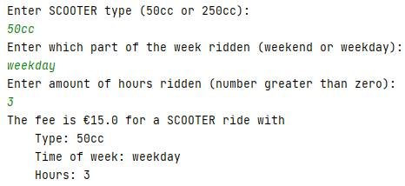

Sample Output 2
